2005 38’ Northlander

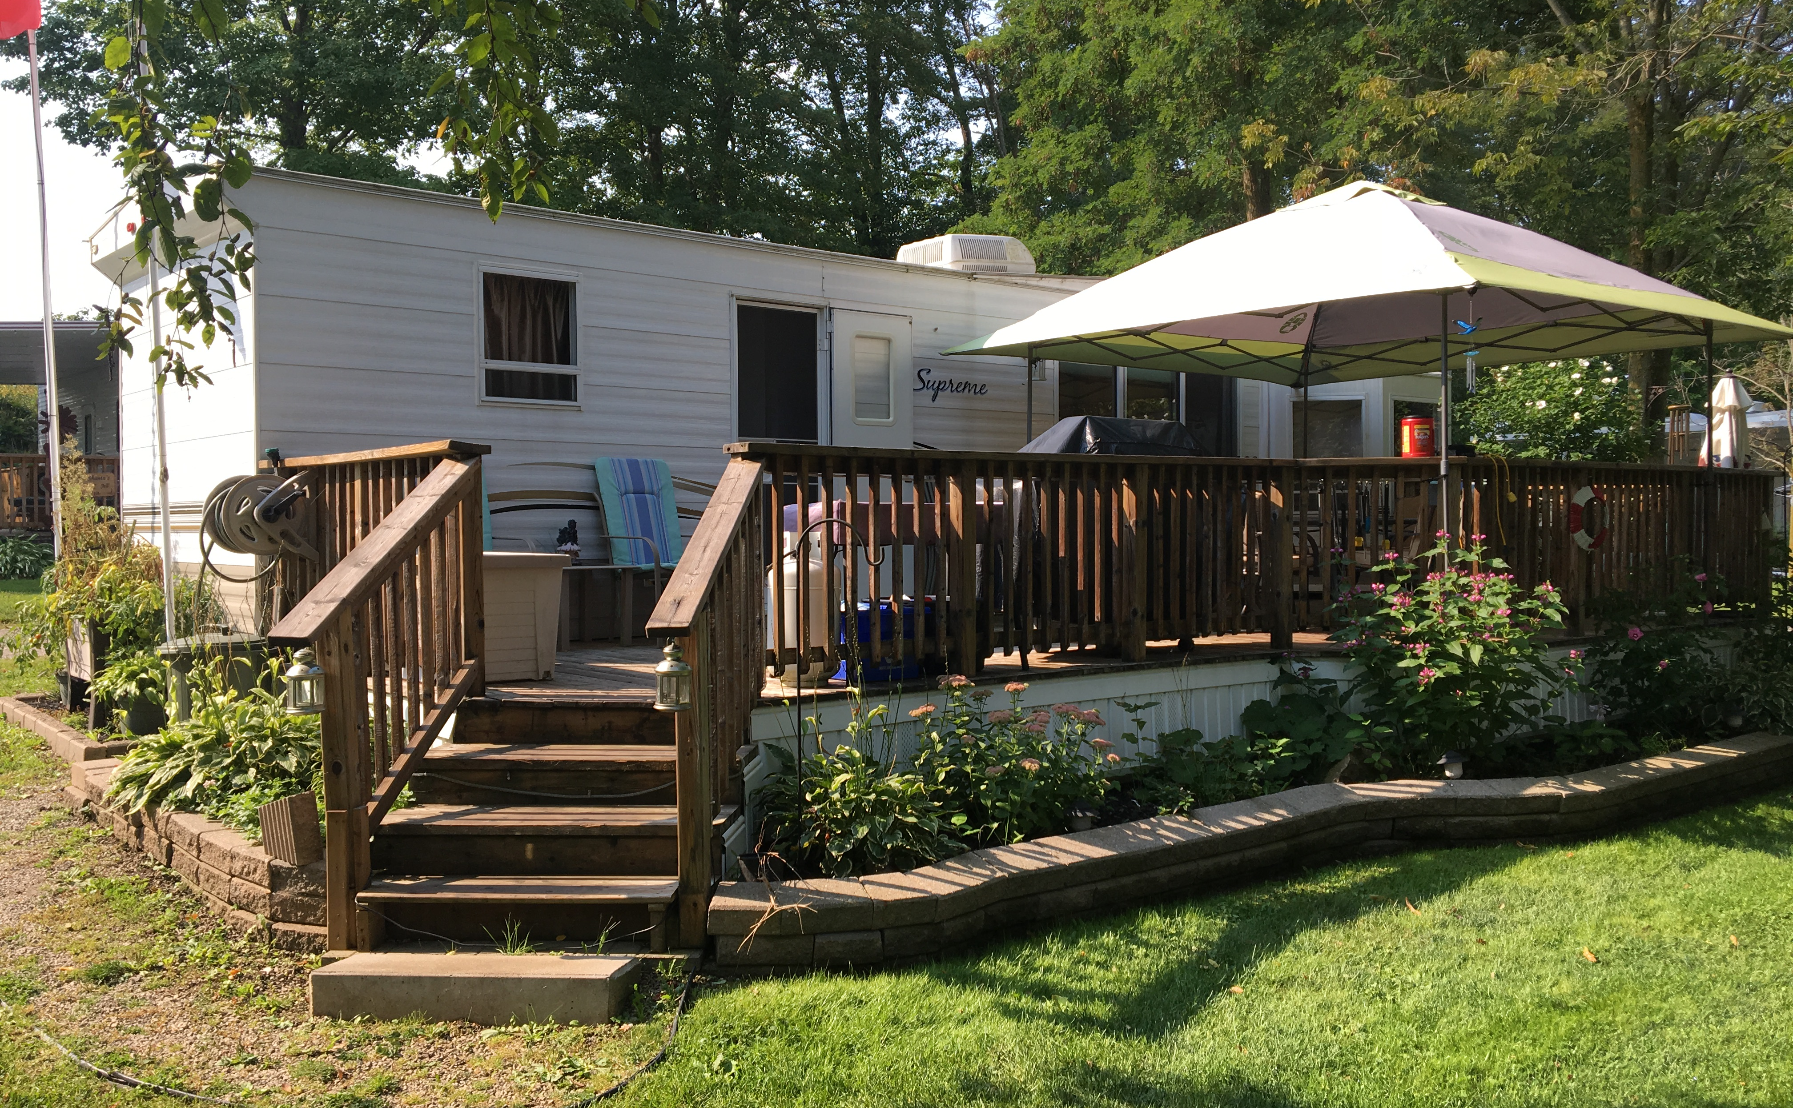

- Front Kitchen, Mid Living Room
- Rear Master Bedroom
- 3 Slide Outs, Full Size Fridge, A/C
- Golf Cart, TV With DVD Player
- Fridge In Shed, 2 x 100lb Propane Tanks
- 10’ x 10’ Shed, 10’ x 36’ Deck
- Located on Site 516

$28,500
Plus Applicable Taxes
Contact Country Gardens RV Park for more details
www.cgrvpark.ca 519-696-3230 1-866-224-0503

