1998 38’ Glendale
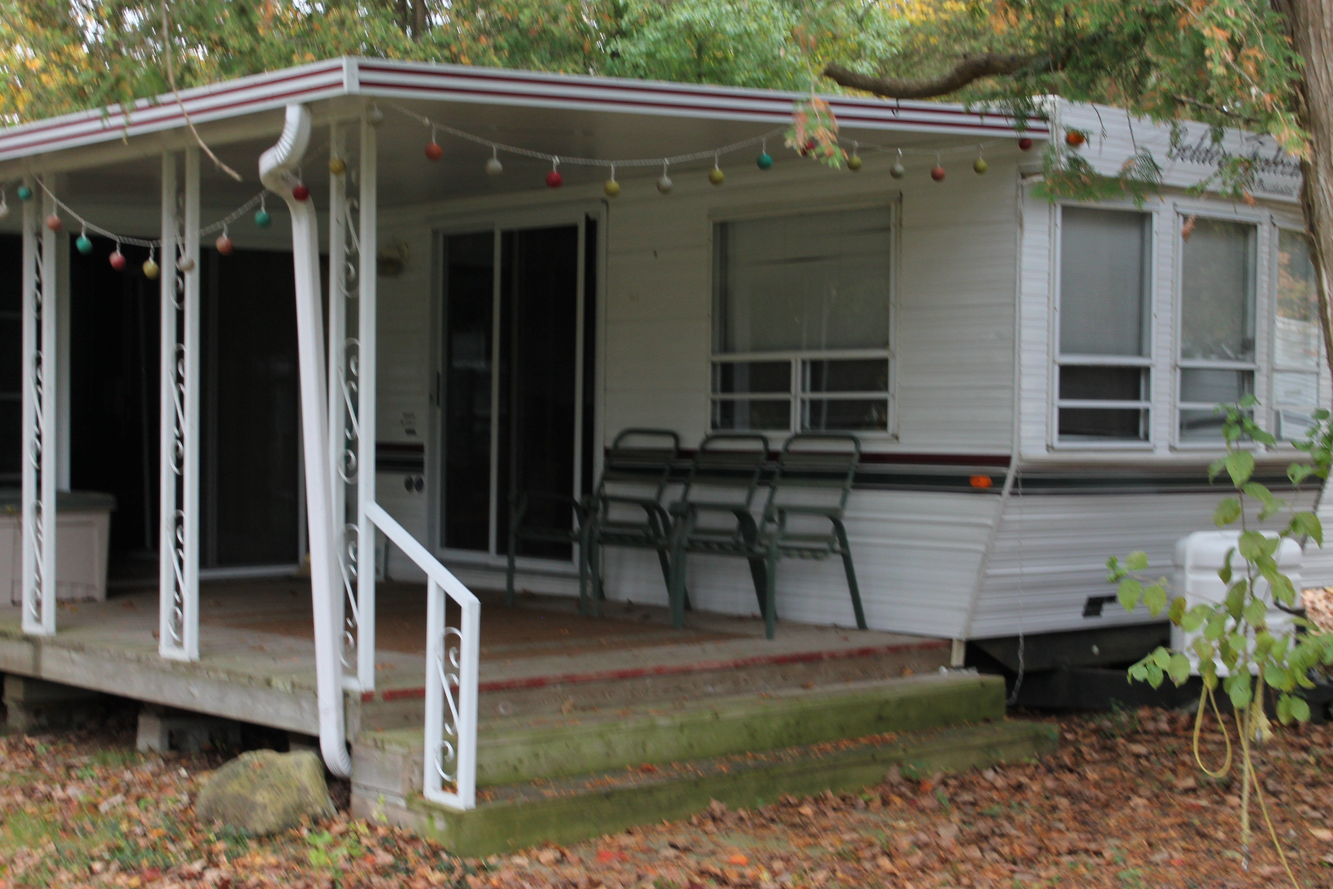

- Two Bedroom, Mid Kitchen, Front Living Room
- Lawnmower, BBQ, Rug, Drapes, Flag Pole
- 8' x 10' Shed, 38' x 10' Deck, 10' x 20' Ad-a-Room
- Located On Site 131

$15,000
Plus Applicable Taxes
Financing is available on this unit, oac
Contact Country Gardens for more details
www.Cgrvpark.ca 519-696-3230 1-866-224-0503

